NATIONAL UNIVERSITY OF MODERN LANGUAGE ISLAMABAD
CCP report


Submitted to:
Sir Hassan Shah
Submitted by:
Zulqarnain Hassan
Roll No: …………………… SP21379
Subject: …………………… computer network
Department: ……………… BSSE-5-Afternoon
Date: ……………………… 23-12-2024

Deployment and Integration of PrimeSoft’s Network Infrastructure

Table of Contents
- Objective
- Problem Statement
- Network Design and Implementation
  - LAN Configuration
  - WAN Configuration
- Connectivity Testing
- Conclusion

1. Objective
The objective of this CCP is to deploy and integrate networking technologies to establish an enterprise-level network infrastructure for PrimeSoft, a software company. The designed network connects four main branches located in Islamabad, Karachi, Lahore, and Multan, ensuring seamless communication, scalability, and reliability.

2. Problem Statement
PrimeSoft requires a robust and scalable network infrastructure to interconnect its four main branches: Islamabad, Karachi, Lahore, and Multan. Each branch operates independently but must be interconnected to ensure efficient communication and data sharing. This project aims to implement an enterprise-level network that supports VLANs, DHCP, dynamic routing, and other critical network services.

3. Network Design and Implementation

3.1 LAN Configuration

Requirements:
- Branches: Four branches (Islamabad, Karachi, Lahore, and Multan) with local area networks.
- Switches: Each branch has three switches configured in a loop topology.
- STP Setup: Implementation of Rapid PVST for efficient spanning tree protocol.
- DHCP Server: Configured for each VLAN.
- VLAN Setup: Two VLANs for each branch, sub-netted using 172.79.0.0,
- PC Connections: Two PCs per VLAN at each branch to verify connectivity.

Implementation:
- Branch Details:
  - Islamabad: VLAN2 (designing department), VLAN2 (Development department)
  - Karachi: VLAN2 (designing department), VLAN2 (Development department)
  - Lahore: VLAN2 (designing department), VLAN2 (Development department)
  - Multan: VLAN2 (designing department), VLAN2 (Development department)
- Switch Setup: Three switches per branch configured in a loop to enable redundancy.
- STP Configuration: Rapid PVST was configured on all switches to prevent loops.
- DHCP Configuration: DHCP servers assigned unique IP ranges to each VLAN.

3.2 WAN Configuration

Requirements:
- Routers: Four routers named city-wise (Islamabad, Karachi, Lahore, Multan).
- Routing Protocol: RIP version 2.
- Encapsulation: PPP encapsulation for WAN connections.
- Connections: Serial connections between routers and Fast Ethernet connections to LANs.

Implementation:
- Router Configuration: Each router was assigned a unique city name and configured with RIP v2 for dynamic routing.
- PPP Encapsulation: Ensured secure WAN connections.
- WAN Topology: Established serial connections between routers and connected LANs using Fast Ethernet ports.

4. Connectivity Testing
Connectivity between all nodes was verified using the following tests:

- Ping: from a pc in Islamabad branch to karachi branch.
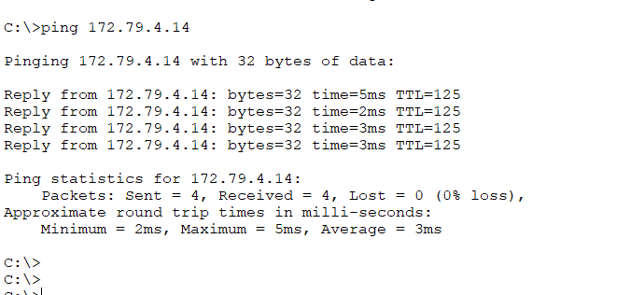
- Traceroute: from a pc in Islamabad branch to Multan branch.
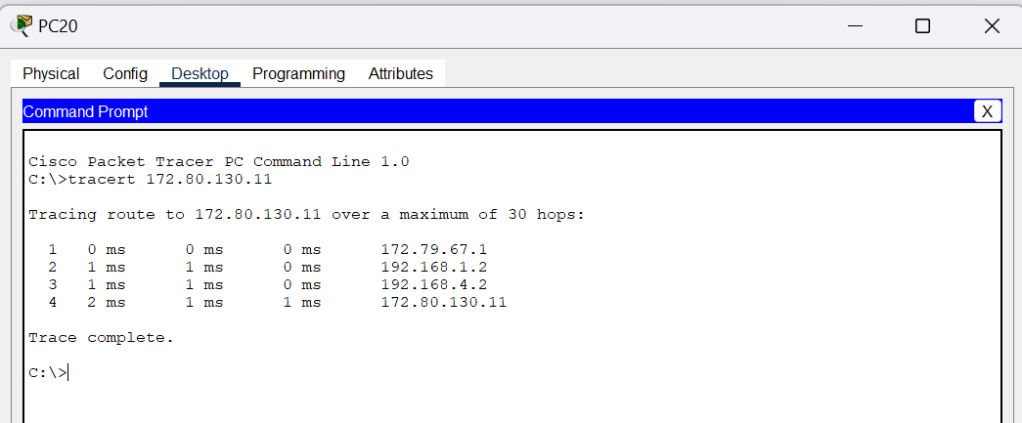

Search through domain name from a pc browser.
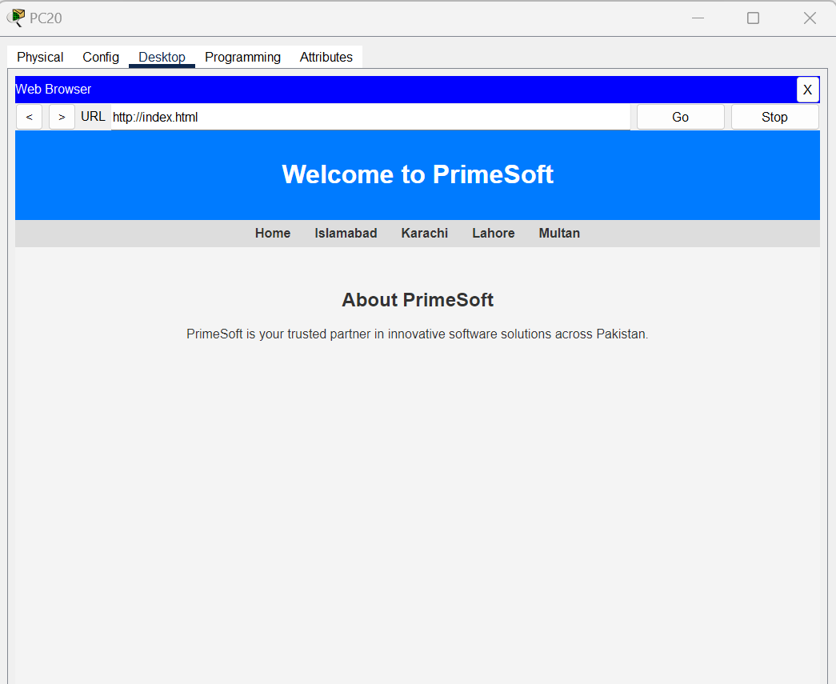

5. Conclusion
The project successfully implemented an enterprise-level network infrastructure interconnecting PrimeSoft’s four branches located in Islamabad, Karachi, Lahore, and Multan. The LAN and WAN configurations ensured seamless connectivity, scalability, and redundancy. All network requirements, including VLAN setup, DHCP servers, and web servers, were met, and connectivity tests confirmed the network’s functionality.

